
Year 8

Mini-Test – Circle and Index Laws

2021

Name: ______________________ Class: ______ Time: 30 minutes Total Mark:____/ 45

Show working and answers on this sheet. Incorrect answers without showing work may be allocated zero marks.
Resources Allowed: 1-page A4 notes (1 side).

Question 1 3 marks
Name the dotted line on each circle:

Diagram | Name |  | Diagram | Name
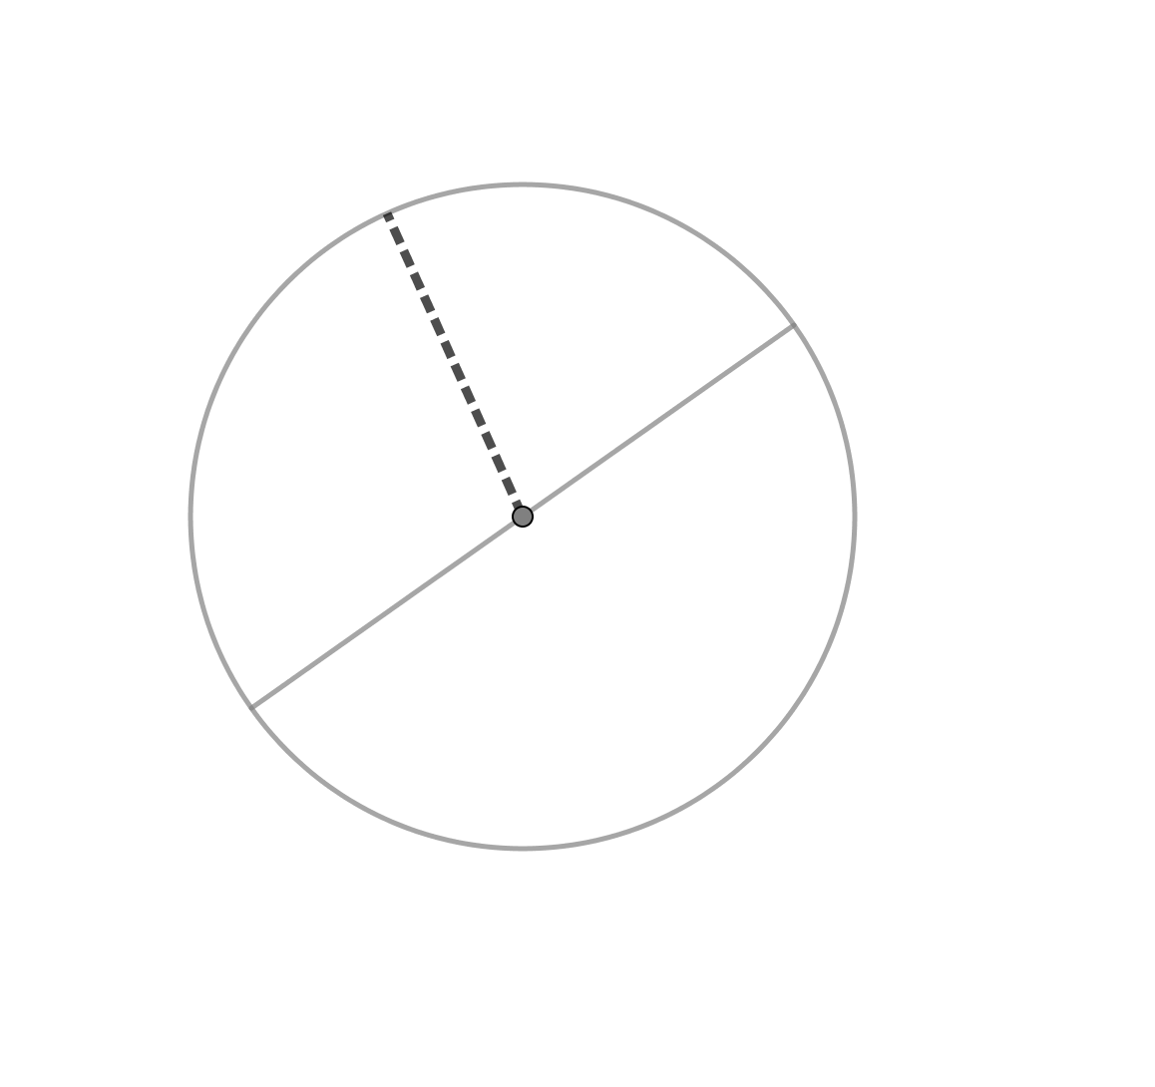 |  |  | 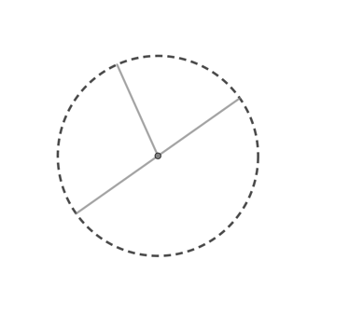
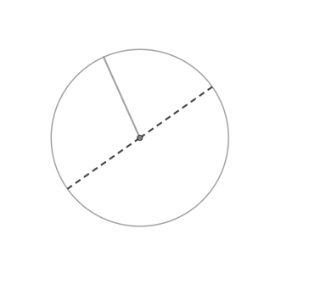

Question 2 18 marks

Find the circumference and area of the following:

Circle | Circumference | Area
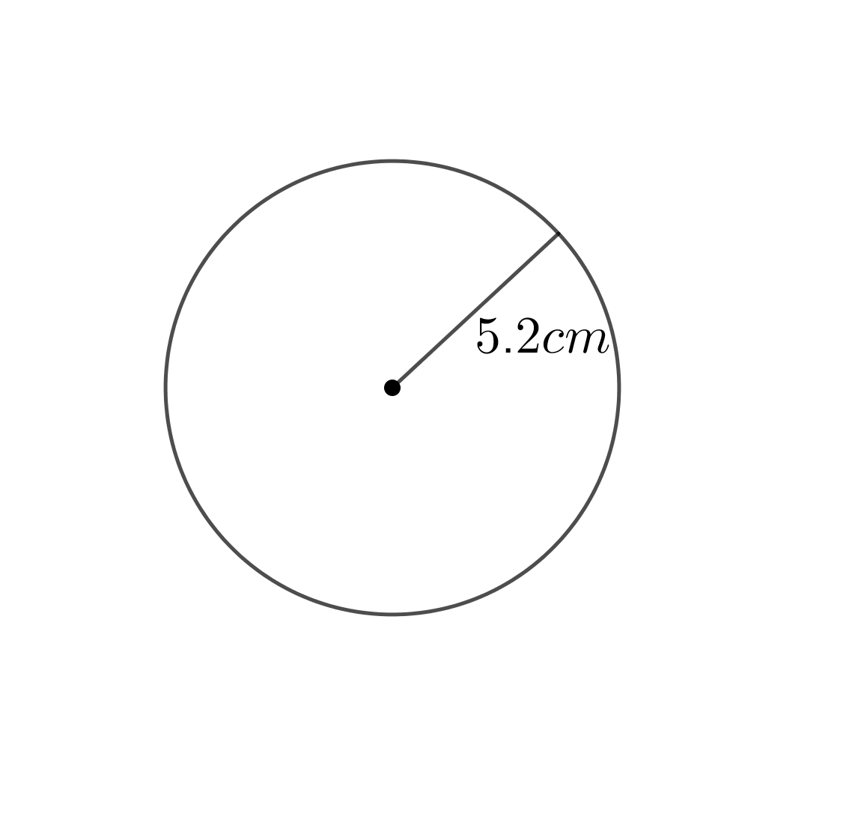
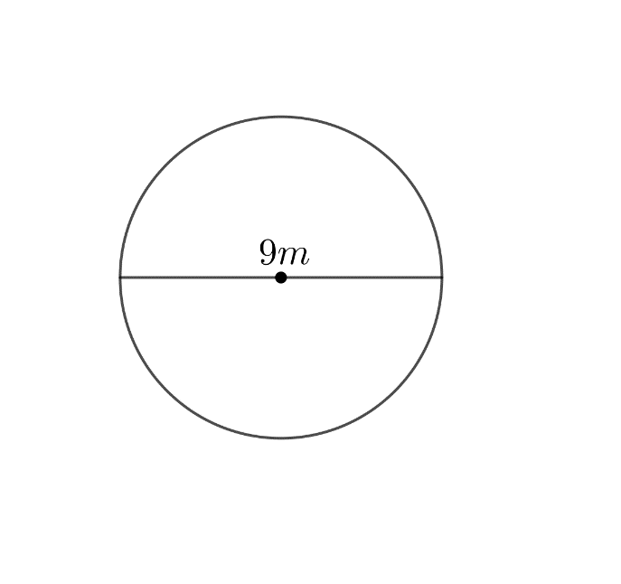
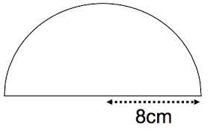
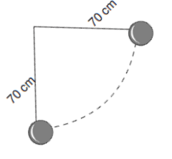
Question 3 6 marks

Complete the following table:

Index Notation | Expanded Notation | Numeral
3²
 | $$5x5x5$$
 |  | 64

Question 4 12 marks

Use Index laws to solve the following (Leave your answer in Index form):
- $4^{5} × 4^{2}=$  - ${10}^{5}÷{10}^{2}=$  - $(b^{5})^{3}=$ | - ${s^{7}(s}^{5})^{3}=$  - $a^{0}=$  - $\frac{m^{6}}{m^{2}}=$ | - $3^{6}×3^{6}÷3^{2}=$  - $\frac{(t^{2})^{3}× 9t^{4}}{3t^{2}}=$

Question 5 3 marks

An adult bike tyre has a diameter of 70cm. How many full turns will the tyre make if the bike travels 5000cm?

Question 6 3 marks

A baker made a doughnut, it has a circumference of 30cm. What is the diameter of the doughnut?

End of Test

